User Documentation: Adding A Student

Description: This query will allow users of the access database system to add a student and their information to the registration database.

Step 1. Navigate to “Student Form” on the left side of your access window and double-click.

Step 2. Enter the data for the student that you are trying to add to the database system, and then click “Enter Student”

Step 3. The student has now been added to the registration database.

User Documentation: Query to Find Professors and Their Course

Description: This query will be used within the access database system to find a professor and which course they are available to teach.

Step 1: Navigate to the “Query Wizard” at the top of the access database.

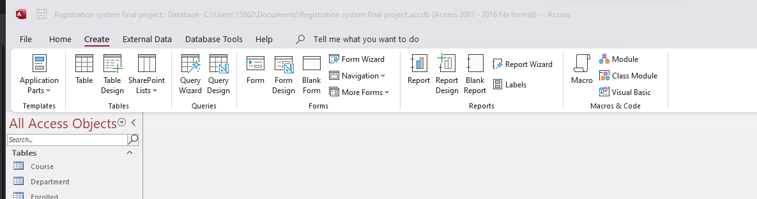

Step 2: Click the “Query Wizard, select “Simple Query”, and left click the “Ok” option.

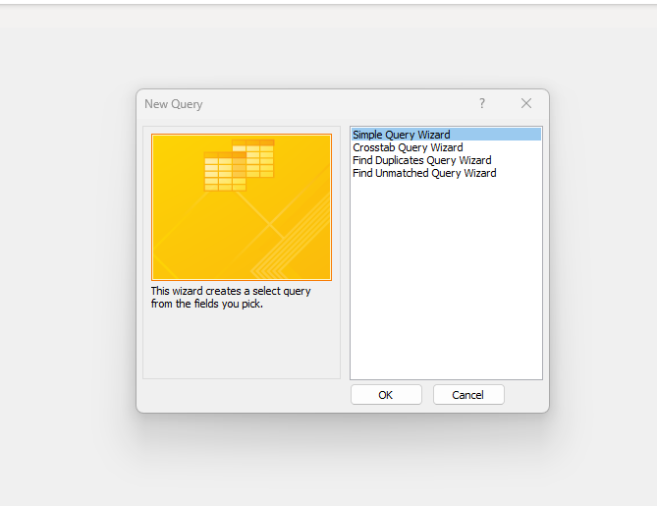

Step 3: Select “FacultyID, FirstName, CourseName”, and then left click the “Next” option.

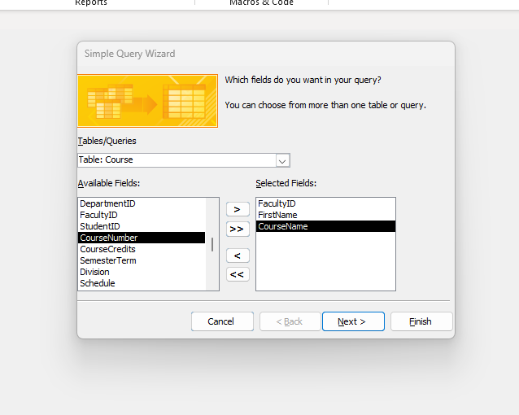

Step 4: Add A title for your query and then click “Finish”

Step 5: You will now be shown available professors for each course that they teach.

